Virginia

Table of Contents

Click the links below to view the selected sections.

Conference Overview
State Director Message
State Delegation Information
Condensed Conference Agenda
Conference Preparation
NLSC Microsite
NLSC Town Hall Meetings
Road to Atlanta Email Campaign
Support Letter Templates
Advisor Best Practices
Pre-NLSC & Post-NLSC Student Reflection Questions
Hotel Courtesies

Conference Experience
Welcome to Atlanta!
Airline Information and Discounts
Airport Transportation Information
Atlanta & GWCC Parking Information
Safety and Security Information
Atlanta Attraction Discounts
Atlanta Restaurants

Conference Programs and Events
General Sessions
SkillsUSA Championships
Credentialing Opportunities
National Courtesy Corp
National Education Team
SkillsUSA Delegates
SkillsUSA LEARN
Community Service Project
SkillsUSA TECHSPO
Immersive Experience - Construction

Registration Information
Scholarships
Advisor Registration Instructions
Accessibility
Hotel Booking Information
Mark your calendars for NLSC 2027

Conference Overview

State Director Message

Dear Advisors,
Congratulations! Your students have worked hard this year and are preparing to attend the 2026 SkillsUSA National Leadership & Skills Conference (NLSC) in Atlanta. On behalf of our state association and board of directors, thank you for your dedication as an advisor and for helping fulfill the SkillsUSA mission of empowering members to become skilled professionals, career-ready leaders, and responsible community members.
From June 1-5, 2026, we will come together for an incredible national conference experience in Atlanta. I know you and your students will make us proud. The NLSC offers meaningful opportunities for every student and educator in attendance.
New and expanded for 2026 — Credential Opportunities at NLSC
This year we will offer new and expanded credentialing opportunities for students and advisors through SkillsUSA: Learn. These credentials help validate technical knowledge and workplace readiness skills, giving students a competitive advantage as they enter the workforce or continue their education. Participating in credential opportunities at NLSC allows students to leave not only inspired but with tangible proof of their skills and career readiness.
Competitors in the SkillsUSA Championships will represent our state as the best in their skill areas. Our state delegates will conduct the business of the organization and help shape the future of SkillsUSA while strengthening their leadership skills. Advisors will grow their classroom toolkits by observing national competitions, networking with industry partners, and participating in professional development opportunities.
All attendees will engage directly with industry through competitions, the TECHSPO tradeshow, credential opportunities, and other conference events. Total attendance is expected to exceed 19,000 students, teachers, and industry partners, making NLSC one of the largest workforce development events in the nation.
This guide outlines the 2026 SkillsUSA NLSC in detail. It is essential that you take time to carefully review all information to effectively prepare both yourself and your students. Students succeed when they are informed in advance and feel well prepared for this incredible opportunity.
Please review this document and reach out with any questions to me or the SkillsUSA Customer Care Team at 844-875-4557. We look forward to seeing you in Atlanta for the 2026 NLSC!
Sincerely,

Joyce Price
SkillsUSA Virginia State Director

State Delegation Information

- State hotel information
Hilton Atlanta
255 Courtland St. NE
Atlanta, Georgia 30303

- Registration fees along with payment instructions
All fees must be mailed to the following address by due date. No refunds after April 22. Price sheet will be posted on website and emailed.
SkillsUSA
Virginia Cooperative Extension State Office
Virginia Tech
115 Hutcheson Hall, 250 Drillfield Drive
Blacksburg, VA 24061

- Travel information (flights, buses, etc.): This packet contains information on suggested travel

- Dates and deadlines
  - March 20, 2026 - Registration & hotel reservation system opens
  - April 22, 2026 - Registration & hotel reservation system closes
  - April 25, 2026 - Conference registration invoices sent to Atlanta
  - April 25, 2026 - Payment due to SkillsUSA Virginia

- Who to contact
  - General questions: CustomerCare@SkillsUSA.org or 877-875-4557
  - Housing reservation questions: SkillsUSANLSC@HPNGlobal.com or 480-998-9770 Ext: 2
  - Accessibility questions: accessibility@skillsusa.org
  - Joyce Price, State Director, director@skillsusava.org

- State delegation meetings
State Welcome Meeting (Monday, June 1, 7 pm)
On Monday, we kick off NLSC with a key gathering to connect with our state delegation and set the stage for an exciting week ahead. This meeting provides essential conference information and is when you’ll receive your chapter’s name badges and other NLSC registration materials.

Celebration Night (Friday, June 5, 8 pm)
Immediately following the Awards Session at State Farm Arena, our state delegation will gather for a brief awards session. Students who earn a particular cut score in each contest will earn a Skill Point Certificate, endorsed by industry and listing the competencies mastered through participation in the contest.
- Honor your state trading pin and state T-shirt design winners
  - Congratulations to Gabbie Davis from Blacksburg High School for winning 1st place in Pin Design at the State Leadership and Skills Conference! Gabbie’s design will be used as our state trading pin.
  - Congratulations to Ira Jadhav from Academies of Loudoun for winning 1st place in T-Shirt Design at the State Leadership and Skills Conference! Ira’s design will be used as our state T-shirt worn at the Champions’ Festival.

Condensed Conference Agenda

Monday, June 1
1 p.m. - 6 p.m. SkillsUSA Store Grand Opening
7 p.m. State Delegation Meeting

Tuesday, June 2
7:30 a.m. - 5 p.m. SkillsUSA Store
8 a.m. - 5:30 p.m. SkillsUSA Championships
8 a.m. - 5:30 p.m. SkillsUSA TECHSPO
9 a.m. - 4:00 p.m. SkillsUSA LEARN
5 p.m. Doors Open for Opening Session
7 p.m. Opening Session

Wednesday, June 3
7:30 a.m. - 5 p.m. SkillsUSA Store
7:30 a.m. - 9 a.m. Call to Action: Advisor’s Session
7:30 a.m. - 5:30 p.m. SkillsUSA Championships
8 a.m. - 5:30 p.m. SkillsUSA TECHSPO
1 p.m. - 4:00 p.m. SkillsUSA LEARN

Thursday, June 4
7:30 a.m. - 2 p.m. SkillsUSA Store
7:30 a.m. - 5 p.m. SkillsUSA Championships
8 a.m. - 5 p.m. SkillsUSA TECHSPO
9 a.m. - 4:00 p.m. SkillsUSA LEARN
6 p.m. - 9:30 p.m. Champions’ Festival

Friday, June 5
9 a.m. - Noon Community Service Project
3 p.m. Doors Open for Awards Session
4 p.m. Awards Session
8 p.m. State Delegation Celebration

Conference Preparation

NLSC Microsite
SkillsUSA has a microsite specifically to help you prepare for your trip to Atlanta. Take on NLSC like a pro and learn more about attraction & airline discounts, conference programs, safety and security, and more!


NLSC Town Hall Meetings
SkillsUSA Advisors! Whether this is your first trip to the SkillsUSA NLSC, or you are a veteran of the conference, we invite you to the NLSC Town Hall. In the session we will review the NLSC schedule, what to expect, traveling tips, and best practices from experienced advisors. This Town Hall will solidify your preparations for Atlanta.
Wednesday, May 20, 2026
4 p.m. ET
Join Zoom Meeting



Road to Atlanta Email Campaign
After NLSC conference registration closes, please check your email for our SkillsUSA Road to Atlanta email series that will be delivered to your inbox. Be sure your email is correct when registering for the conference. The information shared by email will help you and your students prepare for the conference with details about exciting conference programs and events, how to download the NLSC app, maps to navigate the area and much more. Additionally, there will be a post-conference survey to share your feedback.

Support Letter Templates
Below are templates of letters intended to help garner support from your school's administration. These letters are designed specifically for attending NLSC 2026. They aim to facilitate the process of securing approval and assistance to participate in the event.

Advisor Support Letter Template
Student Support Letter Template

Advisor Best Practices

Conference week will really fly by but try to take in as much as possible. This conference provides something for everyone. Best practices: Meet as many people as you can. You will meet fellow advisors who have great ideas; you will meet industry personnel who can advise you. You will meet national staff who are prepared to help you become the best SkillsUSA advisor you can be. And it all starts with a simple hello!

Pre-NLSC & Post-NLSC Student Reflection Questions
As SkillsUSA advisors work to equip their student members for a successful 2026 National Leadership & Skills Conference (NLSC), you are encouraged to take the time to ensure a quality learning experience. Provide these reflection questions to guide your students as they prepare for the NLSC and consider why they are attending and what they can gain from the experience. Student Reflection Questions

Hotel Courtesies
SkillsUSA has a nationwide reputation for upholding high standards. This good reputation allows each of us to take pride in our organization. The following is a list of hotel courtesies and suggestions for students and advisors: Hotel Courtesies

Conference Experience

Welcome to Atlanta!
Atlanta, dubbed as an urban oasis nestled within a forest of towering buildings, boasts expansive green spaces and a multicultural atmosphere, earning it a spot on the Best in Travel list. Serving as both a historical railroad terminus and a modern transportation hub, notably through the world's busiest airport, Hartsfield-Jackson Atlanta International Airport, the city seamlessly blends its rich past with a global outlook. Downtown's highlights include Centennial Olympic Park and its surrounding attractions, while sports enthusiasts can catch major league action at venues like Mercedes-Benz Stadium and State Farm Arena. Atlanta stands as a beacon of Southern charm, creativity, and sophistication, inspiring all who encounter its boundless possibilities.The majority of NLSC functions are hosted at the Georgia World Congress Center and State Farm Arena.


Transportation

Airline Information and Discounts

Hartsfield-Jackson Atlanta international airport provides nonstop service to more than 150 domestic destinations. In 2023 it was celebrated as the world’s most efficient airport by the Air Transportation Research Society. Learn more about navigating the Atlanta airport click here.

Delta Airlines
Delta Airlines offers discounts for NLSC attendees. Go to bit.ly/nlsc26-delta to book your flights or call the Delta Meeting Network at 1-800-328-1111* Monday to Friday from 7 a.m. to 5:30 p.m. (Central time) and refer to Meeting Event Code NM4V2.
*There is no service fee for reservations booked and ticketed via the reservation 800 number.
Southwest Airlines
Southwest Airlines offers discounts for NLSC attendees. Visit bit.ly/SkillsUSA-SW-F26 to book your flights.

United Airlines
United Airlines offers discounts for NLSC attendees. Go to bit.ly/SkillsUSA-united26 to book your flights or call the United Meetings Reservation Desk at (800) 426-1122* Monday to Friday from 7 a.m.to 9 p.m. (Central time) and Saturday or Sunday from 7 a.m. to 5 p.m. (Central time) and use discount code ZRHN852872.
*Booking fees are waived for NLSC reservations.

Airport Transportation Information

DART Airport Hotel Shuttle
SkillsUSA has partnered with Dart Airport Transfers to offer a discounted rate for airport to hotel shuttle and private car services for SkillsUSA attendees. You will receive a discounted rate when you book online using promo code, “SKILLS26.” Visit the custom booking portal by clicking Pick Me Up Dart. Please be sure to book in advance.
Airport Shuttle Service
Adults: $30.00 each way ($5.00 off)
Students: $25.00 each way ($5.00 off)

Airport Shuttle Operating Hours:
Arrival Shuttle Service – 9 a.m. – 9 p.m.
Departure Shuttle Service – 5 a.m. – 5 p.m.

For large group inquiries (30 or more passengers) or groups arriving outside of normal shuttle hours, complete a Pick Me Up Dart Quick Quote Request Form and provide details on your transportation needs and the Dart Airport Shuttles team will get back to you within 48 hours.

MARTA Atlanta’s Rapid Transit
Riding MARTA, Atlanta’s rapid transit system, from the airport to your downtown hotel is easy. Participants will go to the Domestic Terminal, between the North and South baggage claims. Take the Red and Gold lines to the downtown convention district and depart at the station nearest your hotel.

Tips for taking MARTA to and from Hartsfield-Jackson International Airport:
- MARTA’s Airport Station is inside the Domestic Terminal. Travel to the Domestic Terminal, between the North and South baggage claims. Here is the domestic terminal directory: bit.ly/MARTA-TermMap
- Take the Red or Gold lines. They travel directly to and from the Airport Station.
- Plan ahead (or on the go). Use the MARTA On the Go (itsmarta.com/marta-on-the-go.aspx) or trip planner (itsmarta.com/planatrip.aspx) app to get directions and see real-time train schedules.
- MARTA’s fare system uses Breeze Cards. Purchase cards at www.BreezeCard.com ahead of time, at the Breeze Vending Machines in any MARTA rail stations or in person at the Marta Ridestore in the Airport or Five Points stations.
· A reloadable Breeze Card is $2 and then $2.50 for a one-way trip.
· A Breeze ticket is $1 plus the $2.50 fare for a one-way trip.



Atlanta & GWCC Parking Information

Atlanta Parking
Public parking is available throughout Downtown Atlanta. Visit the Downtown Atlanta Public Parking Map for more information.

GWCC Car Parking
The Georgia World Congress Center (GWCC) offers convenient on-campus parking with two surface lots (Blue & Yellow) and three parking decks (Red, Orange & Green) for visitors, attendees, and staff for on-site events. There are thousands of parking spaces to make visiting the GWCC convenient. Look at the GWCC Campus and Area Maps for parking location details.

Daily Parking at the Red, Orange & Green Deck and Yellow & Blue Lot

Multi-day parking passes available:
- 3 days parking pass – Tuesday – Thursday
- 5 days parking pass – Monday – Friday
- 7 days parking pas – Friday – Friday

Pre-purchase parking at this link: bit.ly/GWCC-Parking

Navigate to the SkillsUSA National Leadership & Skills Conference event and click ‘Reserve Parking’. Note if you are renting a vehicle and do not have the license plate number, type in 123456 to bypass this field.

*Parking services has agreed to make special accommodations for our group and allow in and out privileges. Please show your printed or electronic receipt or parking pass when reentering the parking deck.

GWCC Bus and Trailer Parking
The Georgia World Congress Center (GWCC) operates an on-site, 540,000-square-foot Marshalling Yard on Ivan Allen Jr. Blvd. adjacent to the Yellow Lot. The GWCC Marshalling Yard sits just seconds away from the GWCC loading docks and is patrolled 24 hours a day by GWCCA Public Safety officers to ensure safe access to and from the facility during the show.

Daily parking at the Marshalling Yard when pre-purchased.

Pre-purchase parking at this link: bit.ly/GWCC-Parking.
Navigate to the SkillsUSA National Leadership & Skills Conference event and click ‘Reserve Parking’.

Safety and Security Information

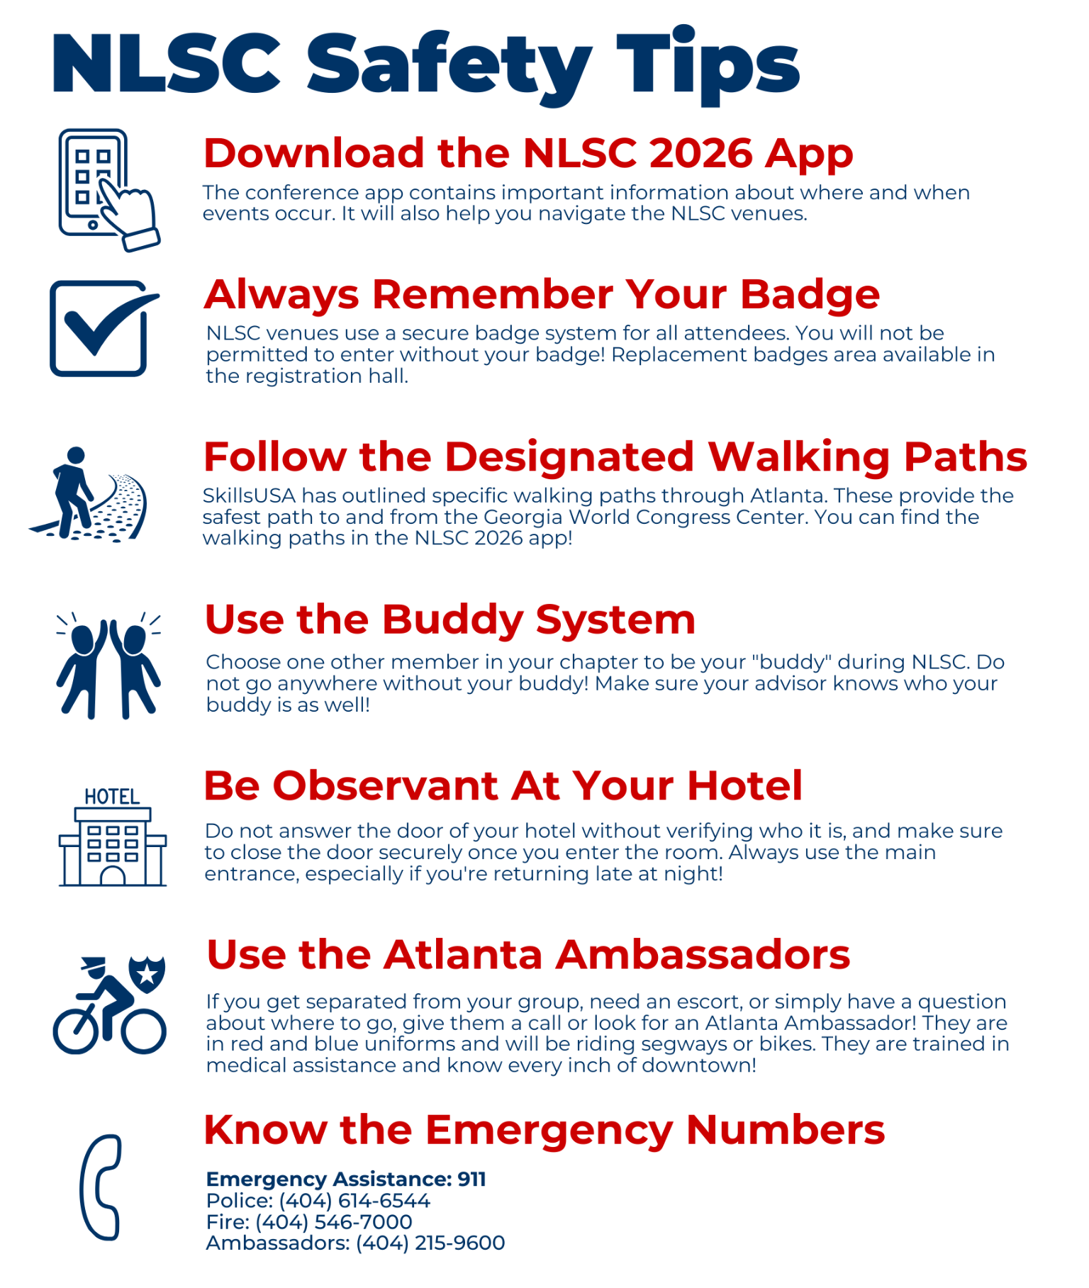

Atlanta Attraction Discounts

Georgia Aquarium
Experience over 11 million gallons of awe-inspiring wonders at Georgia Aquarium, the largest aquarium in the United States. Visit and learn about whale sharks, beluga whales, manta rays, penguins, sea lions, and our newest Sharks! As a friend of Georgia Aquarium, SkillsUSA is happy to present you with exclusive, online-only discounts on a variety of Georgia Aquarium tickets, including general admission, Behind the Seas Tours and animal encounters.

SkillsUSA Anytime Ticket (Before May 15) - $37.99
SkillsUSA Anytime Ticket (After May 15) - $42.99
SkillsUSA Group Order Tickets - $44.99
Learn More

Chick-Fil-A College Football Hall of Fame
The Chick-Fil-A College Football is the home of all things college football. Throw, kick a field goal and experience 94,000 square feet of the storied tradition of college football. Enjoy More than 50 engaging and interactive exhibits. A shrine to the greatest to ever play or coach the game.
SkillsUSA Price: $26
Groups of 15 or more: $22
Learn More



Atlanta Restaurants



Conference Programs and Events

General Sessions
*The session run-of-shows are tentative and subject to change as session schedules are finalized.

Opening Session | Tuesday, June 2 at 7 p.m. | Doors: 6 p.m. | Pre-Session: 6:25 p.m.
SkillsUSA Official attire or career competition attire is recommended. Business professional attire acceptable.

The Opening Session is where the magic of NLSC truly begins… a powerful conference kickoff and

celebration. As the lights come up and the energy builds, we’ll honor our WorldSkills competitors and

recognize the 2026 Advisor of the Year, while taking a moment to celebrate the dedication and impact of

all SkillsUSA advisors nationwide. We’ll introduce the dedicated candidates for the 2026–2027 National

Officer Team and hear an uplifting message from SkillsUSA Executive Director, Chelle Travis, that will

set the tone for an unforgettable week ahead. Add in an electrifying entertainment performance and a

powerful keynote from IndyCar Champion Josef Newgarden — presented by Snap-on Incorporated —

and you’ll leave energized, motivated and ready to take on the week as we officially launch NLSC 2026.

Awards Session | Friday, June 5 at 4 p.m. | Doors: 3 p.m. | Pre-Session: 3:25 p.m.
SkillsUSA official attire or career competition attire. Winners not wearing approved attire will not be allowed on stage and will receive their medallion off-stage.

The Awards Session is the pinnacle of NLSC — a moment to reflect, recognize and celebrate a week
defined by achievement, growth and unforgettable experiences. Together, we’ll honor the 2026 Models of
Excellence and witness the election of the new National Officer Team while applauding the incredible
legacy of the outgoing 2025–2026 team. Anticipation will build as we unveil the next annual theme and
announce next year’s keynote speaker. The evening will culminate with the highly anticipated
presentation of the 2026 SkillsUSA Championships Awards, where the nation’s best and brightest are
recognized for their exceptional skill and dedication.
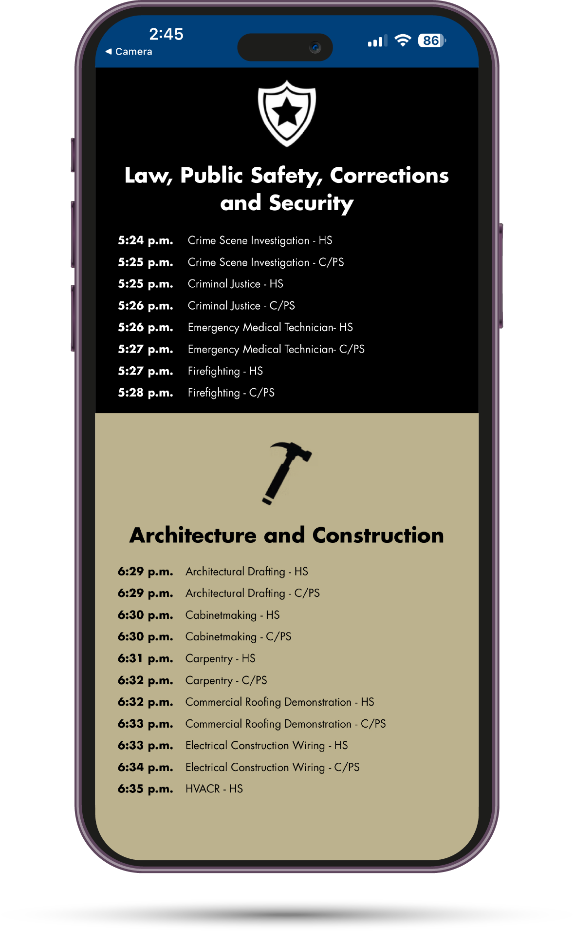

Our come-and-go session format, featuring a published awards order, allows awards session attendees to arrive and depart based on the estimated time that their competition(s) will be awarded on stage. Attendees can access full instructions and the awards session schedule live in the NLSC 2026 conference app.

SkillsUSA Championships

The SkillsUSA Championships program assesses and recognizes career and technical education students. It engages students by testing their skills against standards for entry-level workers in the skilled trades through authentic skill demonstrations. Students are evaluated by expert representatives of business, industry and organized labor. Visit the link below to view the SkillsUSA Competitor Checklist, which includes information about SkillsUSA Technical Standards, Online Submission Requirements, Online Testing, and Competition Updates.


Competition Updates
A competition update covers anything that is not listed in the official SkillsUSA Championships Technical Standards and that a competitor and/or advisor needs to be aware of and bring and/or complete for the national competition. Updates are posted frequently leading up to NLSC. Please check back regularly!

Online Test(s)
SkillsUSA Championships national competitors will receive login credentials to access their online test(s) by May 5, 2026. National competitors will need to identify a proctor and complete the online proctor agreement prior to taking their online test(s). The online testing window is May 5 – May 22, 2026. All required online test(s) must be completed by 5 p.m. ET on Friday, May 22, 2026.

Online Submission Requirements
SkillsUSA Championships national competitors must complete their online submission(s) by May 22 2026, at 5 p.m. ET. The upload(s) will be completed via SkillsUSA’s secure platform which will open in early May 2026. Check the current SkillsUSA Technical Standards for your competition to learn about any required national pre-conference online submissions.

Competition Material Shipping Resources
Competition Materials Shipping Instructions
Competitions Materials Move-In/Move-Out Instructions

SkillsUSA Winners List and Winners Photos
SkillsUSA will announce winners on Friday night at the Awards Session, provide lists of winners to SkillsUSA state directors and then post winners on the SkillsUSA website immediately after NLSC. In addition, detailed scores will be posted on the SkillsUSA website by August 1 and these can be located using your contestant number and birthdate.

SkillsUSA will post winners' photos on the website after the national conference. These downloadable photos are taken backstage of all medalists as they go to collect their prizes.

Credentialing Opportunities

There will be several opportunities at NLSC 2026 for both advisors and students to sit for a quality credential exam from Autodesk, FANUC, NC3, and more. Space is limited, so registration will be on a first come, first served basis.



National Courtesy Corp

The National Courtesy Corps is an elite group of high school students, college/postsecondary students, advisors and chaperones who are selected to represent their state delegation while assisting the national organization in conducting the NLSC. Courtesy Corps members work with and build a network of industry and educational experts while developing Framework skills, building friendships and having fun.



National Education Team

The National Education Team (NET) assists the national technical committees in conducting and managing the SkillsUSA Championships and communicates to advisors the industry expectations for the quality of instruction and professional development in occupational areas represented in the SkillsUSA Championships. NET members may also be called upon throughout the year for their insights and expertise.



SkillsUSA Delegates

SkillsUSA is a student-led organization, where student members are charged with the responsibility of governing the affairs associated with the organization bylaws. The SkillsUSA Delegate Program engages state-identified delegates to represent their respective state association in introducing, debating, modifying and voting upon delegate items that may include organization bylaws, and the SkillsUSA national elections. Delegates receive training to develop their responsibility and decision-making skills while building their peer network throughout the delegate processes.



SkillsUSA LEARN

SkillsUSA LEARN is reimagining professional development at NLSC to deliver high-quality, engaging learning experiences that are practical, relevant and grounded in the SkillsUSA Framework.
SkillsUSA LEARN is comprised of six tracks:
- Student Development - for students to develop their personal, workplace, and technical skills
- Student Credentialing - for students to earn industry-recognized credentials
- CTE Instructor Innovation and Development - for instructors to improve instruction
- Advisor Development - for advisors to develop chapters
- Advisor/Instructor Credentialing (non-licensure) - for educators to earn or be able to administer industry-recognized credentials
- CTE Administrator/Leadership Development - for local school administrators
Registration for professional development sessions is included in your NLSC registration for all educators. Credentialing opportunities may require an additional fee.

Check the NLSC 2026 App for session dates, times and locations.



Community Service Project

The Community Service Project provides students a meaningful, hands-on opportunity to live out the SkillsUSA mission, while making a tangible impact on the City of Atlanta. Through service, students apply leadership, teamwork, professionalism and technical skills beyond the competition floor, reinforcing that workforce readiness includes responsibility to others.
This year, there are three service project options: donating items to City of Refuge, Foundation for Hospital Art PaintFest, and building beds for Sleep in Heavenly Peace. Learn more about all three options



SkillsUSA TECHSPO

As a CTE destination, SkillsUSA TECHSPO showcases the latest technology and its application by our future workforce, teachers, and experts. Over 200 exhibitors at SkillsUSA TECHSPO are placed alongside national career competitions and leadership sessions that are shaping and celebrating our nation’s career-ready students. Across three exhibition floors, interactive experiences inspire participants while industry connections are forged to enhance classrooms and develop the country’s talent pipeline.



Immersive Experience

The Immersive Experience: Construction event is a three-day, hands-on workforce development program designed to help students experience the job before they get the job. Through authentic, industry-led learning, participants apply technical and employability skills in real-world construction settings while exploring career pathways alongside industry professionals.



Registration Information

Scholarships

Numerous college/post-secondary scholarships are available to active members of SkillsUSA through SkillsUSA and our partners. Financial assistance to attend national SkillsUSA events is also offered. SkillsUSA student eligibility varies by scholarship. Members can view detailed information about available scholarships and apply for scholarships by at the link below:



Advisor Registration Instructions
Register competitors, student participants, parents or anyone attending who wants access to the Opening Session and the Awards Session, access to the SkillsUSA Conference floor including competitions and exhibits and educational workshops or other events.

Log-on to the Conference Registration site using your advisor log-on credentials to register attendees for the National Leadership and Skills Conference (NLSC): www.skillsusa-register.org/Login.aspx. Only the advisor or school personnel should be registering attendees. Below is a short description of the registrant types.
Registrant Types
● Contestant: All students competing in a career competition should register in this category. This includes interview competitors for American Spirit, Chapter Display, Promotional Bulletin Board, Occupational Health and Safety and Outstanding Chapter
● Advisor: SkillsUSA advisors or educators attending conference.
● National Education Team and Courtesy Corp Volunteers: Register using the volunteer link. An invitation with this link will be sent by the national SkillsUSA Championships team. Do not register these volunteers with your state association as the fee will not be waived if registered with your school attendees.
● Administrator: Principal, Assistant Principal, Counselor, Chancellor, Dean, President, Vice President, Director, Department Head, CTE Director or any other administrator
● Participant: Chapter members, state officers and delegates. Students who are models for Esthetics or Nail Care and who are back-ups to competitors should also register in this category. Students registering as a participant must be a SkillsUSA member.
● Models of Excellence: By Invitation Only: Participants who have been notified by the SkillsUSA national office that have achieved the highest honor of the Chapter Excellence Program should register in this category. These registrants must be SkillsUSA members by March 1 and will be interviewed as Models of Excellence at NLSC.
● Make48 Contestant: By Invitation Only: Participants who will be competing as part of the regional Make48 Playoff event should register under this type. Students should be registered SkillsUSA members in their respective local chapter by March 1 to be eligible to compete. This event is made up of 3 students and 1 advisor.
● Guest: Chaperones, family members, non-member students and professionals and other attendees not listed above who wish to attend the entire conference and State Farm Arena sessions.
● Children: Tickets for entertainment venues, or any event not mentioned in the children’s registration descriptions below are not part of the child’s registration. These admissions can be purchased separately onsite.
Child — Free registration (age 10 and under) Registration includes access to conference floor at Georgia World Congress Center only. Admission to the Champions Festival and general sessions at State Farm Arena are not included. Purchase the Child Session Pass to include admission to the general sessions and Champions Festival.
Child Session Pass – Paid Registration (ages 10 and under) Registration includes access to conference floor at Georgia World Congress Center, Champions Festival, and admission to the general sessions at State Farm Arena.

Children ages three and under may sit on an adult’s lap at the State Farm Arena general sessions at no charge. A separate seat is not reserved. Purchase a Child Session Pass to reserve a seat for children aged three and under.
Register for Conference
Competitors must be registered SkillsUSA members by the state deadline or no later than the national deadline of March 1 to compete at nationals and the school membership invoices must be paid before competitors can register.
- Log on to the registration site and click the tab Conference>My Registrations.
- Select the event; SkillsUSA National Leadership & Skills Conference in the drop-down event menu.
- Participants previously registered for past state conferences may be copied to NLSC: Click the button Look Up Previous Regs at the bottom of the screen to locate registrations from a previous conference and quickly register for NLSC. NOTE: This feature will only work if all membership invoices are paid in full for your school. You must ensure all data and registrant type are carried over to the NLSC record accurately.
- Click the Add Registrant button at the top of the screen to manually register new attendees. Follow the prompts. Be sure to select registered members from the drop-down name list. Only manually type names of attendees who are not members at the school.

Individual Registration Records
- Complete all the information in each individual registration record. It is critical to provide accurate birth dates for competitors, onsite emergency contacts for all participants, and complete the Americans with Disability Act (ADA), Education and Dietary accommodations section if applicable.
- If applicable, in the Add-On Events section, select Leverage (pre-conference for state officers), Community Service (advisors and students) OR Immersive Experience: Construction (NEW for Students!). Additional registration fees apply to the Leverage pre-conference event.
- Your state may be offering other add-ons. In the Optional Fees section of each individual registration record click the button Add to display a list of possible options. Select the quantity and click Save.
- ADA/Education/Dietary Accommodations- If the attendee needs accommodation, the advisor should check the boxes that apply in each section.
  - Only check the boxes or add information in the Details screen if an accommodation is needed. Otherwise, please skip this section. A blank hard copy of the Conference Registration and Liability form can be printed and handed out to attendees to collect the accommodation information. See information on the form below.
- Once names are added and individual registration records are completed click the Submit Registration button to validate your registration information and to issue an invoice if your state is using the invoicing in the system.
  - NOTE: Once a name is added to the site, they are considered registered regardless of whether the Submit Registration button was clicked. Be sure to advise your state director before the registration deadline of anyone who is no longer attending.

Conference Registration Liability and Release Form
● The Advisor is responsible for providing the Code of Conduct to students and other attendees they register. Provide the hard copy registration and liability form and return to the individual registration record to check the box in the attestation section next to I agree. See bullet below on how to access and print a blank fillable NLSC form that can be given to attendees.
● Once the name is registered, click the FORM link displayed to the left of the name for a copy of the completed online Code of Conduct and Liability form for individual attendees.
● A blank fillable NLSC form can be printed ahead of time and given to the participant to fill out or have a parent sign. The ADA/Education/ Dietary questions will be part of the online form. Click the tab Conference > NLSC Conference Liability and Release Form. The form should then be returned to the advisor or designated school person to enter the data.

Home Address
You must provide a home address for competitors. Competitor awards and corporate gifts may be mailed to home addresses.

Emergency Contact
Emergency contact information is required for all participants.
Name Badges
Name badges must be worn to be admitted to all NLSC functions. Please remind your students to remember to have their badge before leaving the hotel to avoid a return trip back to the hotel.
Please attach collectable pins to lanyards and not directly on the badge holder. All information displayed on the badge must be visible.
Cancellation and Refund Policy
Schools are responsible for paying for all registrants that cancel after the registration deadline. Cancellations made after the deadline are not eligible for a refund/credit.

Accessibility
SkillsUSA strives to ensure inclusive participation in all of our programs, including NLSC. As we prepare for NLSC in Atlanta, please review the information below about accommodations, and information about our key conference venues.
Contact SkillsUSA Accessibility Team
- Accommodations Request Form: All attendees may request accommodations through the Accommodations Request Form.
- Registration System: Students and some attendees may request accommodations via the online NLSC registration system.
- In Person: Connect with a SkillsUSA associate at the Accessibility Help Desk, located at the NLSC Registration area for help.


Hotel Booking Information

Hotels will be booked using the Passkey system through HPN Global. HPN’s professional housing team will partner with you to streamline and automate the reservation booking process for SkillsUSA NLSC.

Head Advisor from each school will need to fill out the hotel spreadsheet.
Spreadsheet must contain School name, address, contact information for each advisor attending
Each room must have names of each person staying in that room.

Hotel reservations are due to Joyce Price, director@skillsusava.org, April 22.

Mark your calendars for NLSC 2027

